Checkout issues:

Checked the shipping charges by selecting country =India, State=Telangana, Zip=123454

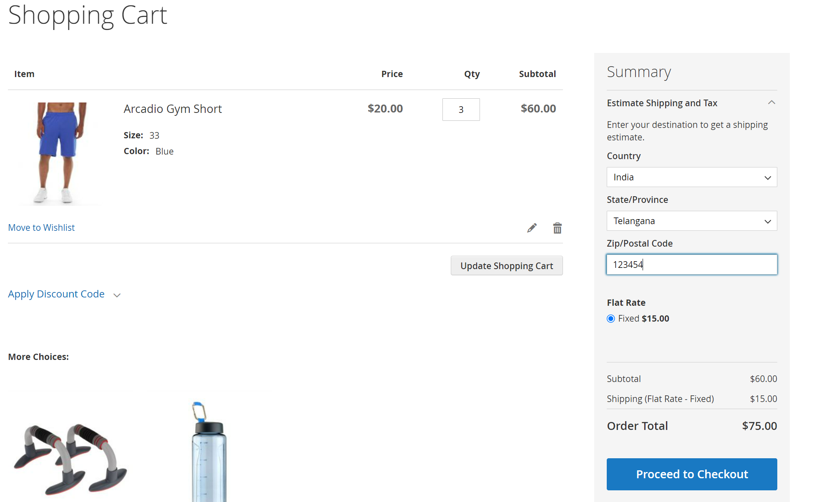

Updated the Country to Chile

When the country value is updated then state, zip fields should be reset to default values.

Instead values of previous selection is being displayed there.

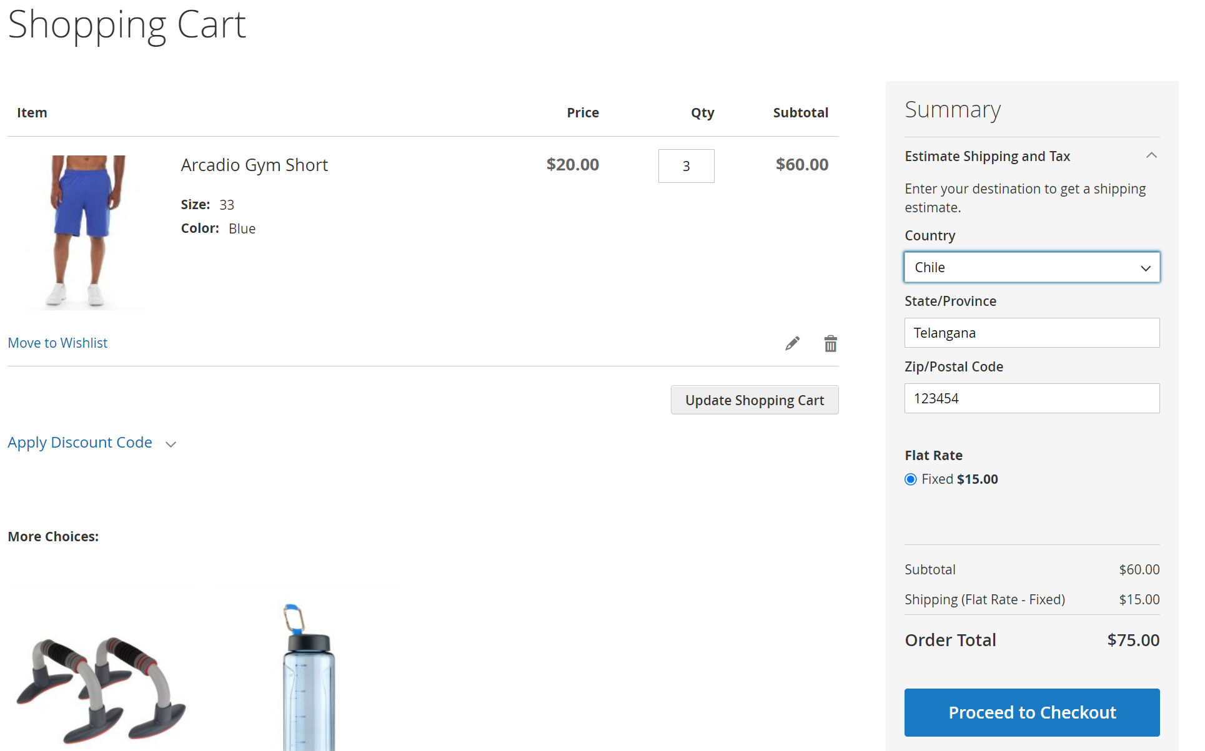

Changed country to Chile but State, Zip is not reset to default , Still State=Telangana, Zip=123454 is being displayed.

Expected behavior: When the country value is updated then state, zip fields should be reset to default values.

2. Able to enter alphabets in phone number field

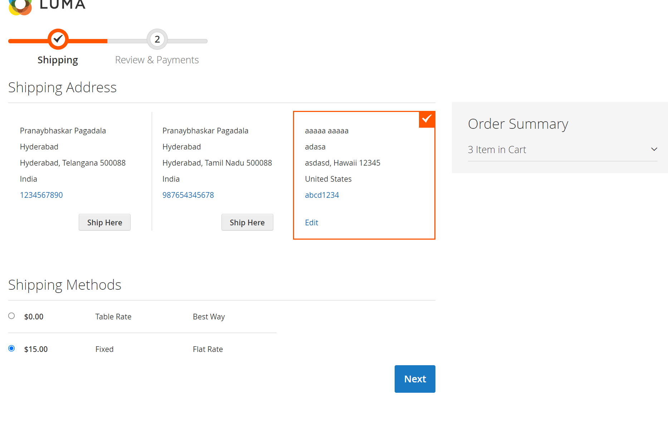

Entered phone number as abcd1234 and able to create the shipping address.

Expected behavior: Error should be displayed saying Enter Phone number in valid format

3. Unable to edit existing address

